
Author: Sarah Michele Chen

Grade Level: K-4

Presentations: I’m flexible and will present as many as time allows. My presentation lasts 30-40 minutes and includes an arts and crafts project making beetles and a Chinese language and culture lesson.

Group size: Classroom setting

Equipment needed: None

Website: https://superbeetlebook.com

Email: sarahmchb@gmail.com

Twitter: @superbeetlebook

Other info: I will bring my own books to sell. SUPERBEETLE is also available through my website, Amazon, and retail bookstores.

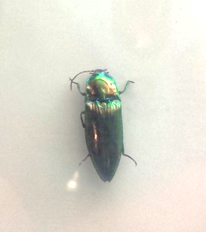
From the Author:

SUPERBEETLE is inspired from my own experience visiting my grandmother in Taiwan when I was a girl. I remember being terrified by the big exotic bugs I saw there which gave me the idea for a book.

Through my research, I discovered that rainbow click beetles are an endangered species in Taiwan so I wanted to illustrate the importance of protecting our planet. I discovered this beautiful beetle at the Natural History Museum in Taiwan which became my muse for SUPERBEETLE:

I also wanted the story to convey how much I loved meeting my grandmother as a young girl while exploring my Chinese heritage. Not to mention showcasing all the yummy food that Taiwan has to offer!

For My School Visit:

I discuss:

• The importance of learning about your own heritage and embracing your culture. It’s fun to explore who you are and where your family came from.

• Being half-Chinese and half-Canadian, I wanted to write a book that featured characters that looked like me and were from a multicultural background.

• Growing up an only child, books were my constant companions. I knew that’s what I wanted to do someday, create a whole world for a child like me. It’s hard work and takes a lot of perseverance but it’s worth it to see your book in the world. That’s something that you—and only you—created!

• Writing is rewriting and revising! SUPERBEETLE actually started as a middle grade short story. My publisher suggested I turn it into a children’s chapter book. I had no experience writing a children’s chapter book but I read as many as I could before writing my own. The entire process from coming up with the concept, researching, writing it, and seeing the story come to life through the fantastic illustrations is one of the most rewarding things I’ve ever done. I can’t wait to do it again.

My presentation includes:

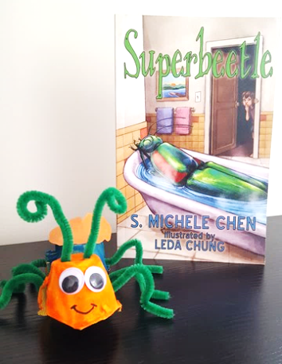
1) An arts and crafts projects where the students make their own easy-to-do Superbeetles using all supplies that I bring: a painted egg carton, pipe cleaners, googly eyes, and construction paper wings. Students learn the anatomy of a beetle plus some interesting facts.

2) A Chinese cultural lesson: I bring flash cards with the Chinese words that are in the book, like “thank you,” “help,” and “family.” Students learn their meaning, how to pronounce them, and why they are important to the story.

Book:

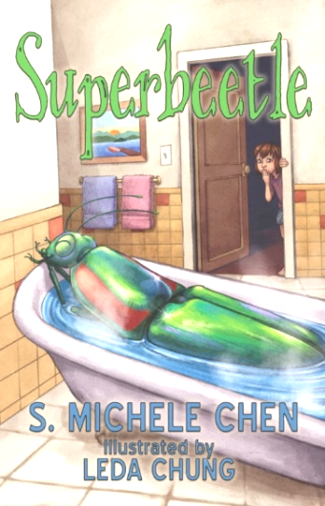
Superbeetle
A tale of a big bug and a girl with a big heart…
Eight-year-old Hong goes to Taiwan with her dad to visit her grandmother for the first time. She finds two BIG problems. First, there is an enormous beetle that fills the entire bathtub and Hong is scared of bugs! Second, her grandmother’s dumpling shop is in trouble and she may be forced to sell it.

Hong can’t bear to see her grandmother sad plus she’s been enjoying helping her dad in the shop. But Hong learns that if you have a curious mind and an open heart, you may receive help at the most unexpected moments and from the most unusual places.

SUPERBEETLE is a fun fantastical tale about bugs! Big bugs! Including the beautiful beetle that eight-year-old Hong finds in a bathtub when she is visiting her grandmother in Taiwan. Not since CHARLOTTE’S WEB has one bug done so much good for a young girl and a family in need.

Reviews:

5 Star Amazon.com review

This is a very cute book, a multicultural early reader. Hong goes with her father to visit her grandmother in Taiwan. She's freaked out by the bugs she encounters until she meets the beautiful and mysterious Superbeetle, big as a bathtub. Superbeetle comes and goes, and only Hong's new friend Chi-chi even believes her that Superbeetle exists. And then Hong's devotion to the giant beetle leads to a discovery that may just save her grandmother's shop. Full of small delightful details of Chinese food and language.

5 Star Amazon.com review

This is a terrific book for young readers. Simultaneously realistic and magical, seamlessly shifting the young female protagonist between a very real family situation and a magical alternative reality. The story takes place in Taiwan, and one thing I appreciated was the author providing, right in the text of the story, helpful tips on how to pronounce words that would unfamiliar to young American readers. It should seem intrusive, but it doesn't, it's just really useful so the reader can "say" the words in his or her head while reading.

Testimonial:

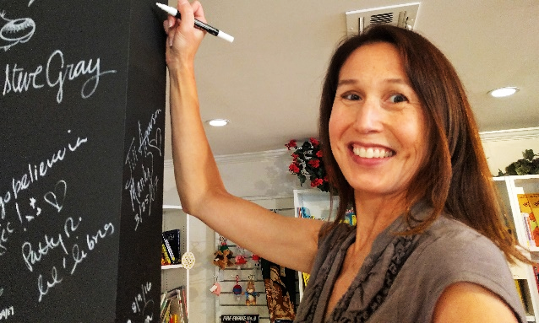
Susie Alexander, owner of Once Upon a Storybook

Sarah Michele visited Once Upon a Storybook (Tustin’s unique children’s bookstore) for an author event in September 2017. We were thrilled to host an author of early chapter books, and Sarah’s book is especially noteworthy because it has cross-cultural appeal. Her story, SUPERBEETLE, uses a Chinese American family and has many Chinese elements that will be relatable to Asian families and a great education for non-Asian families. Her event at the store was well received, and we’ve heard that kids are enjoying her realistic fantasy! Hurray for Superbeetle!

Biography:

S. Michele Chen lives in Southern California but visits her family in Taiwan frequently because the bugs no longer scare her (okay, maybe a little bit). She has published numerous crime fiction short stories and an award-winning novella under a secret identity, and she is a member of SCBWI. This is her first children’s book and hopefully not her last.

© 2017 by The Friends of the Children’s Library; Huntington Beach, CA

