Instructions for Egg Carton Superbeetle!
The Superbeetle craft project is fairly correct for a beetle from an anatomic standpoint -- three body parts (head, thorax and abdomen), 6 legs, 2 antennae, and 2 wings. Some steps can be done beforehand by an adult.

Materials:
- Cardboard egg carton - you need three cups attached
- Scissors
- Tempra paint (multiple colors for a beautiful rainbow beetle)
- Paint brush
- 4 pipe cleaners (chenille in any color) -- three for legs and one for the antenna
- Construction paper
- Sharp pencil
- Googly eyes
- Black marker
- Glue

Craft Instructions:
- Cut a strip of cups (3 cups) from the egg carton -- adults can do this before craft time. Cardboard egg cartons work better with the paint than foam.
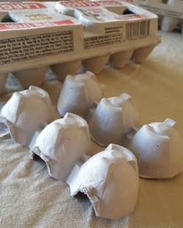
- Paint the cups and let dry.
- Using a sharp pencil, poke two holes in the top of the first cup -- adults can do this step before craft time.
- From inside the cup, poke both ends of the pipe cleaner through the pencil holes (one end through each hole) to make antennae. You can twirl the antennae around a pencil to make them curly.
- Using a sharp pencil, poke one hole on each side of each cup (6 holes in total) -- again, adults can do this step.
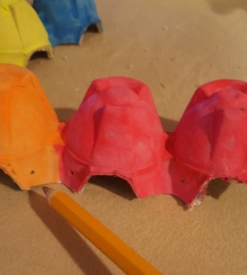
- Push a pipe cleaner through the holes in the first cup.
  - Make the same amount of pipe cleaner stick out the sides -- these are two legs -- you can bend little feet into the ends of the pipe cleaner if you like.
  - Repeat with the second cup and third cup
  - You should end up with 6 legs when you're through
- Draw and cut the pattern for wings using heavy construction paper, cardboard, or the top of an egg carton works great (adults can do this step before craft time).
- Cut wings out of the construction paper using the wing pattern. You can use multiple colors.
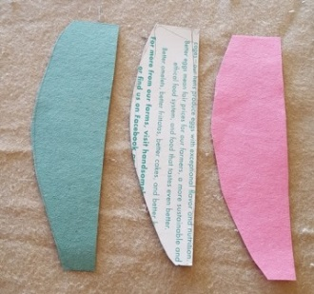
- Glue the wings onto the second cup.
- Glue the Googly eyes onto the head (you could substitute 2 cheerios or 2 fruit loops).
- Optional: draw on a mouth with black marker.
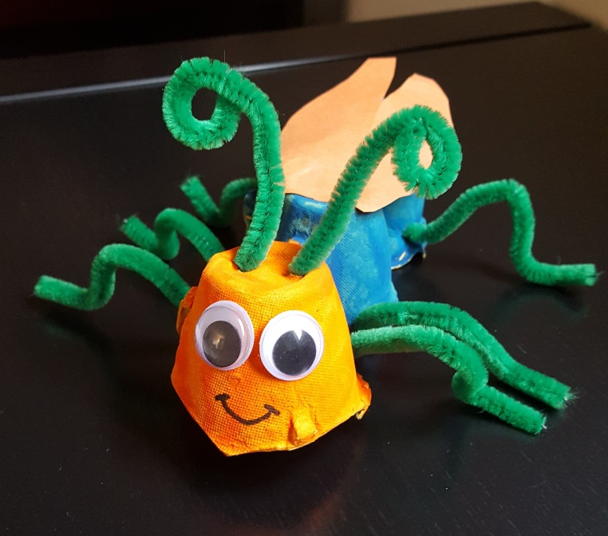
SUPERBEETLE!

